**☁️ Cloud Concepts**

⌨️ ([00:13:51](https://www.youtube.com/watch?v=NKEFWyqJ5XA&t=831s)) What is Cloud Computing

⌨️ ([00:17:15](https://www.youtube.com/watch?v=NKEFWyqJ5XA&t=1035s)) Common Cloud Services

⌨️ ([00:18:35](https://www.youtube.com/watch?v=NKEFWyqJ5XA&t=1115s)) What is Microsoft and Azure

⌨️ ([00:19:52](https://www.youtube.com/watch?v=NKEFWyqJ5XA&t=1192s)) Benefits of Cloud Computing

⌨️ ([00:21:25](https://www.youtube.com/watch?v=NKEFWyqJ5XA&t=1285s)) Types of Cloud Computing   
⌨️ ([00:23:39](https://www.youtube.com/watch?v=NKEFWyqJ5XA&t=1419s)) Types of Cloud Computing Responsibilities

* SAAS
* PAAS
* IAAS

⌨️ ([00:25:16](https://www.youtube.com/watch?v=NKEFWyqJ5XA&t=1516s)) Cloud Deployment Models

* Public Cloud
* Private Cloud
* Hybrid Cloud
* Cross Cloud (Azure Arc)

⌨️ ([00:29:57](https://www.youtube.com/watch?v=NKEFWyqJ5XA&t=1797s)) Total Cost of Ownership

|  |  |
| --- | --- |
| **On Premise** | **Azure** |
| Software License Fees | Subscription Fees |
| Implementation | Implementation |
| Configuration | Configuration |
| Training | Training |
| Physical Security |  |
| Hardware |  |
| IT Personal |  |
| Maintenance |  |

⌨️ ([00:32:06](https://www.youtube.com/watch?v=NKEFWyqJ5XA&t=1926s)) CAPEX vs OPEX

|  |  |
| --- | --- |
| **Capital Expenditure** | **Operational Expenditure** |
| Server Costs | Leasing Software and customizing Features |
| Storage | Training Employees in Cloud Services |
| Network | Paying for Cloud Support |
| Backup and Archive | Billing based on cloud metrics eg. |
| DataCenter Costs | * Compute usage |
| Technical Personal | * Storage usage |

⌨️ ([00:34:08](https://www.youtube.com/watch?v=NKEFWyqJ5XA&t=2048s)) Cloud Architecture Terminologies

⌨️ ([00:35:08](https://www.youtube.com/watch?v=NKEFWyqJ5XA&t=2108s)) High Availability

⌨️ ([00:36:49](https://www.youtube.com/watch?v=NKEFWyqJ5XA&t=2209s)) High Scalability

⌨️ ([00:37:46](https://www.youtube.com/watch?v=NKEFWyqJ5XA&t=2266s)) High Elasticity

⌨️ ([00:39:35](https://www.youtube.com/watch?v=NKEFWyqJ5XA&t=2375s)) Fault Tolerance

⌨️ ([00:39:39](https://www.youtube.com/watch?v=NKEFWyqJ5XA&t=2379s)) High Durability

**☁️ Evolution of Compute**

⌨️ ([00:40:26](https://www.youtube.com/watch?v=NKEFWyqJ5XA&t=2426s)) Dedicated Services

⌨️ ([00:42:13](https://www.youtube.com/watch?v=NKEFWyqJ5XA&t=2533s)) Virtual Machines

* Hypervisor is software layer that lets you the VMs
* You will pay extra for an underutilized Virtual Machine
* Multiple apps on a single VM can result in conflicts in resource sharing

⌨️ ([00:43:38](https://www.youtube.com/watch?v=NKEFWyqJ5XA&t=2618s)) Containers

* VM running multiple containers
* Docker Daemon used to run the containers
* You can max utilize the maximum capacity which is more cost effective
* Your containers share the same underlying OS so containers are more efficient that VMs
* Multiple apps run side by side without being limited to the same OS requirements and will not cause conflicts during resource sharing

⌨️ ([00:44:52](https://www.youtube.com/watch?v=NKEFWyqJ5XA&t=2692s)) Functions

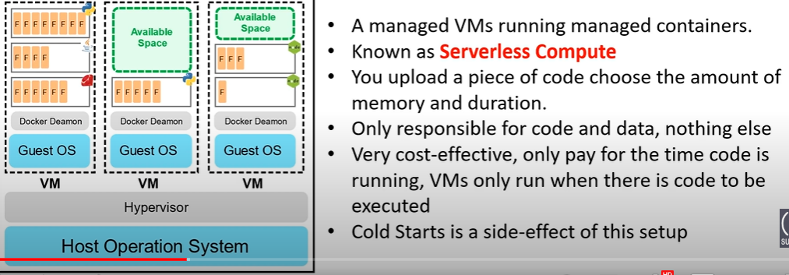

**☁️ Global Infrastructure**

* ⌨️ ([00:46:19](https://www.youtube.com/watch?v=NKEFWyqJ5XA&t=2779s)) Regions and Geographies
* ⌨️ ([00:49:05](https://www.youtube.com/watch?v=NKEFWyqJ5XA&t=2945s)) Paired Regions
* ⌨️ ([00:50:34](https://www.youtube.com/watch?v=NKEFWyqJ5XA&t=3034s)) Region Types and Service Availability
* ⌨️ ([00:52:55](https://www.youtube.com/watch?v=NKEFWyqJ5XA&t=3175s)) Special Regions
* ⌨️ ([00:54:14](https://www.youtube.com/watch?v=NKEFWyqJ5XA&t=3254s)) Availability Zones
* ⌨️ ([00:56:20](https://www.youtube.com/watch?v=NKEFWyqJ5XA&t=3380s)) AZ Supported Regions
* ⌨️ ([00:57:51](https://www.youtube.com/watch?v=NKEFWyqJ5XA&t=3471s)) Availability Sets Fault and Update Domains

**☁️ Getting Started**

* ⌨️ ([01:02:08](https://www.youtube.com/watch?v=NKEFWyqJ5XA&t=3728s)) Creating an Azure Account
* ⌨️ ([01:06:16](https://www.youtube.com/watch?v=NKEFWyqJ5XA&t=3976s)) Azure Portal Layout

**☁️ Technology Overview**

* **⌨️ (**[**01:06:57**](https://www.youtube.com/watch?v=NKEFWyqJ5XA&t=4017s)**) Computing Services**
* 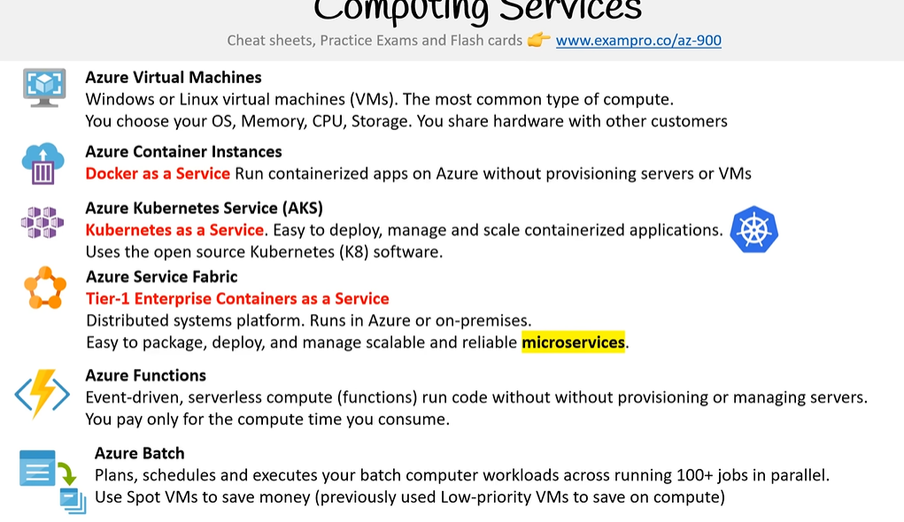
* **⌨️ (**[**01:10:21**](https://www.youtube.com/watch?v=NKEFWyqJ5XA&t=4221s)**) Storage Services**
* 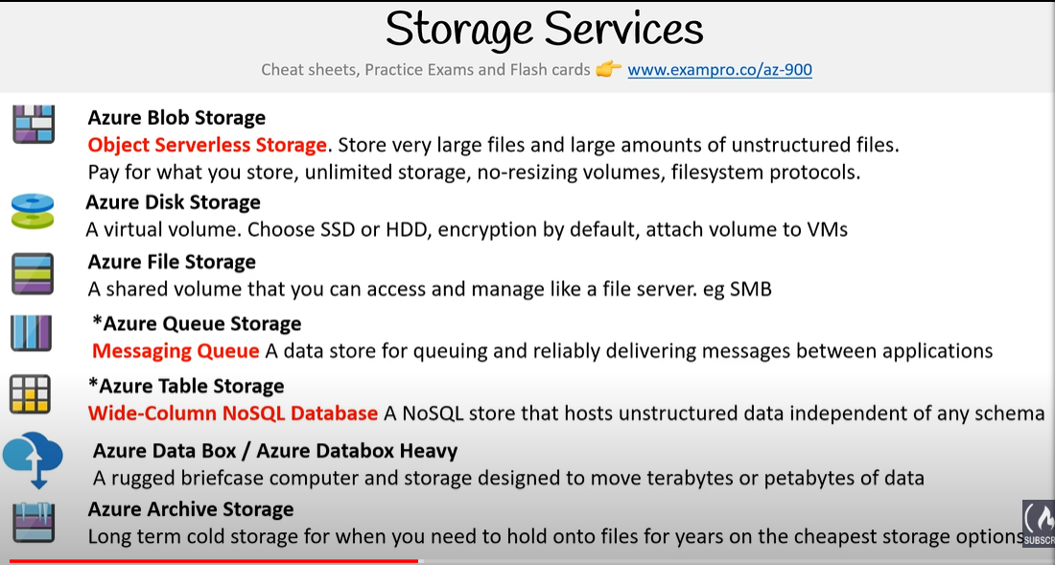
* **Azure Data Lake Storage**

A centralized repository that allows you to store all your structured and unstructured data of any scale.

* **⌨️ (**[**01:14:02**](https://www.youtube.com/watch?v=NKEFWyqJ5XA&t=4442s)**) Database Services**

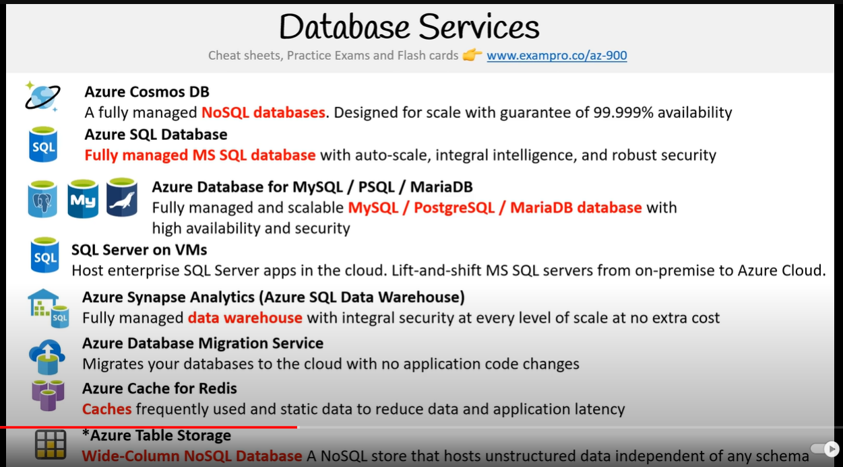

* **⌨️ (**[**01:16:38**](https://www.youtube.com/watch?v=NKEFWyqJ5XA&t=4598s)**) Application Integration**

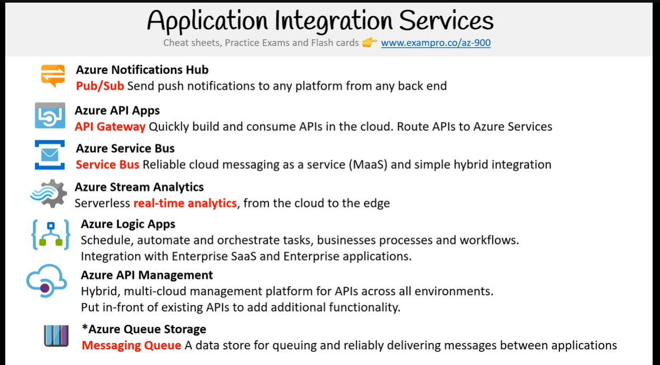

* **⌨️ (**[**01:19:01**](https://www.youtube.com/watch?v=NKEFWyqJ5XA&t=4741s)**) Developer and Mobile Tools**

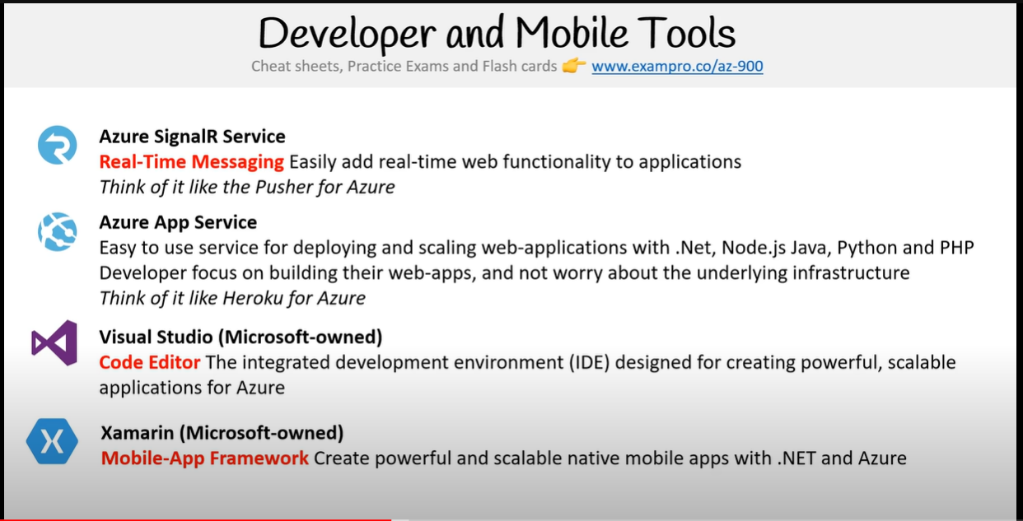

* **⌨️ (**[**01:20:36**](https://www.youtube.com/watch?v=NKEFWyqJ5XA&t=4836s)**) Azure DevOps Services**

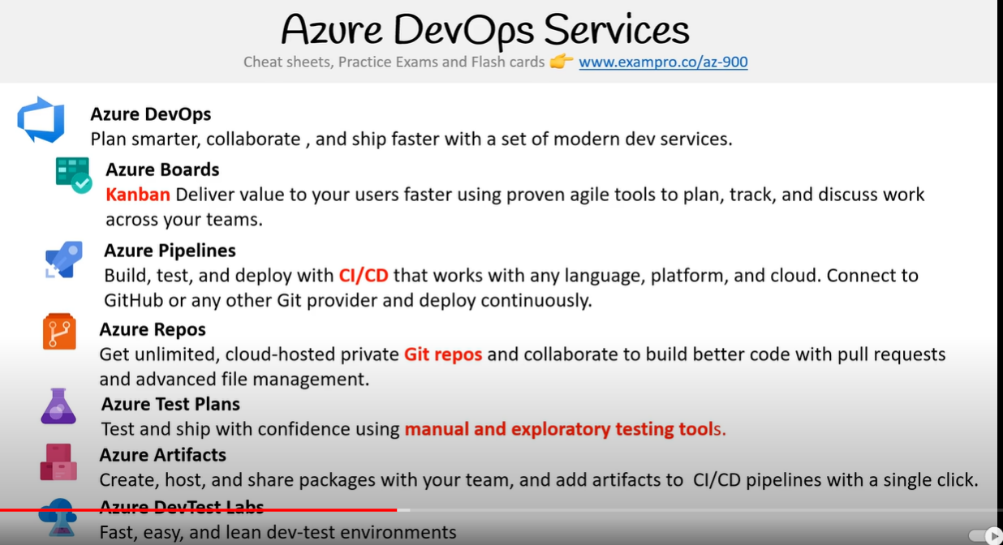

* **⌨️ (**[**01:22:32**](https://www.youtube.com/watch?v=NKEFWyqJ5XA&t=4952s)**) Azure Resource Manager ARM**

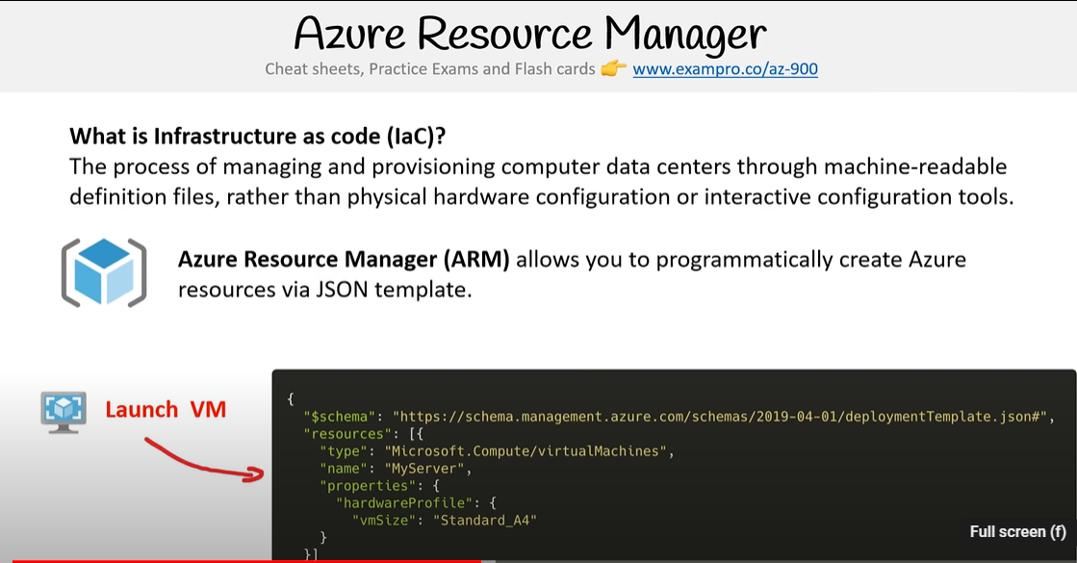

* **⌨️ (**[**01:23:51**](https://www.youtube.com/watch?v=NKEFWyqJ5XA&t=5031s)**) Azure QuickStart Templates**

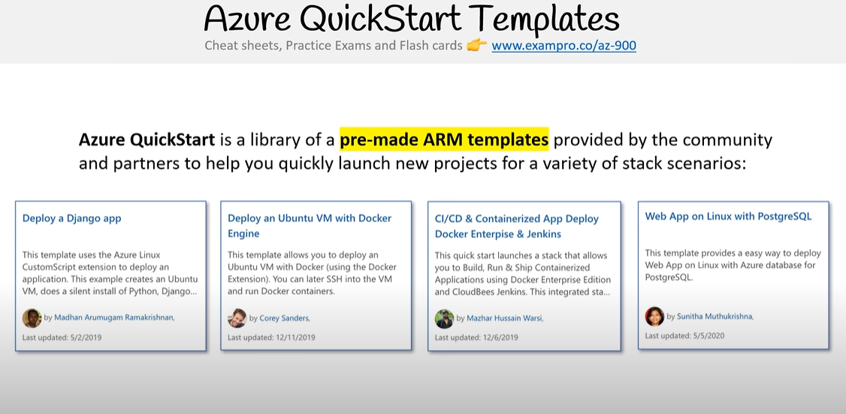

<https://learn.microsoft.com/en-us/samples/browse/?expanded=azure&products=azure-resource-manager>

* **⌨️ (**[**01:25:02**](https://www.youtube.com/watch?v=NKEFWyqJ5XA&t=5102s)**) vNets and Subnets**

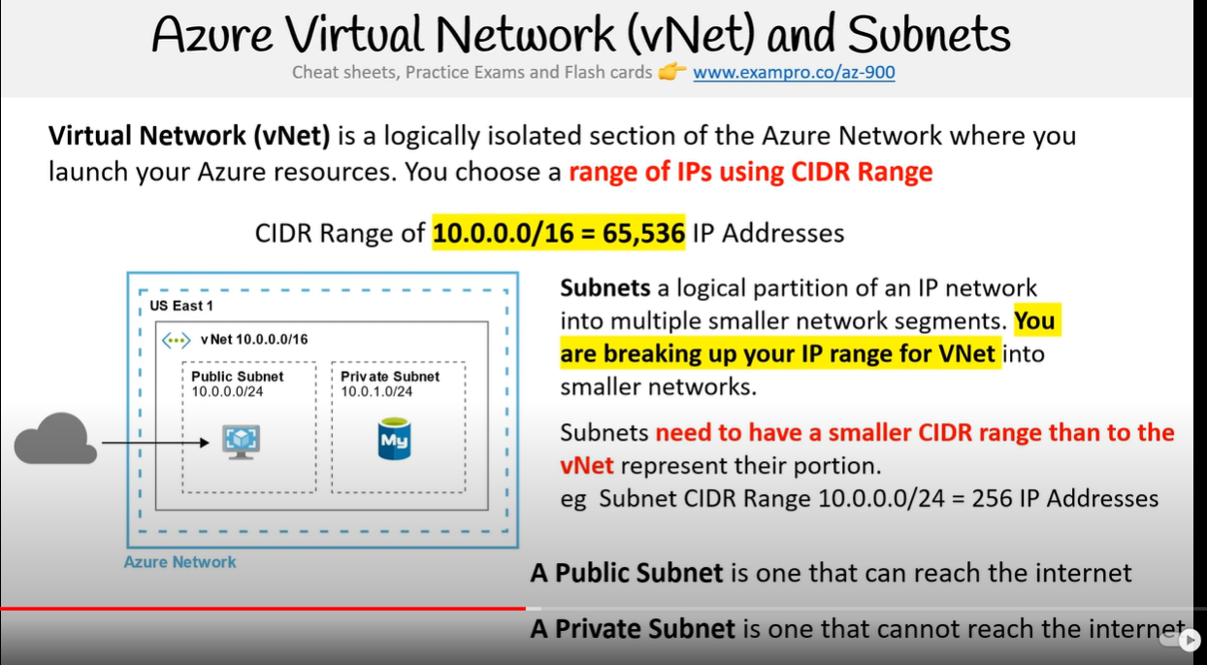

* **⌨️ (**[**01:27:46**](https://www.youtube.com/watch?v=NKEFWyqJ5XA&t=5266s)**) Cloud Native Networking Services**

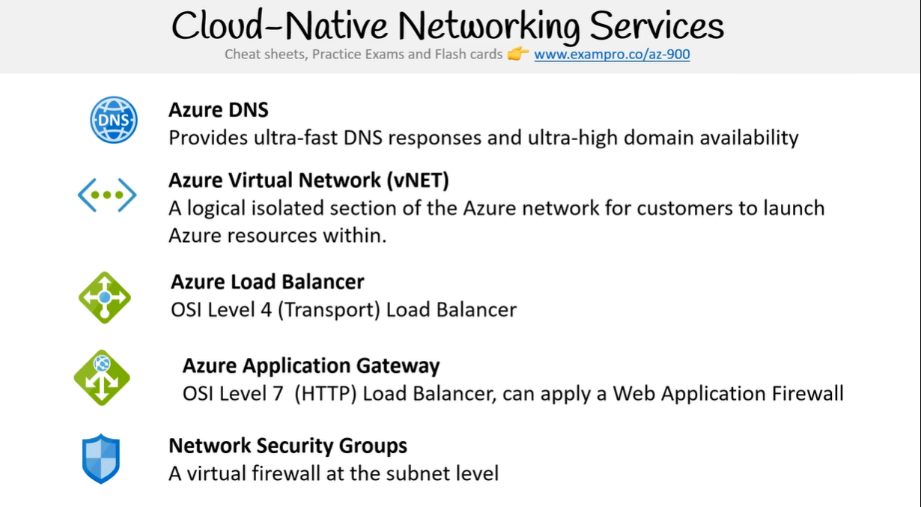

* **⌨️ (**[**01:29:48**](https://www.youtube.com/watch?v=NKEFWyqJ5XA&t=5388s)**) Enterprise Hybrid Networking Services**

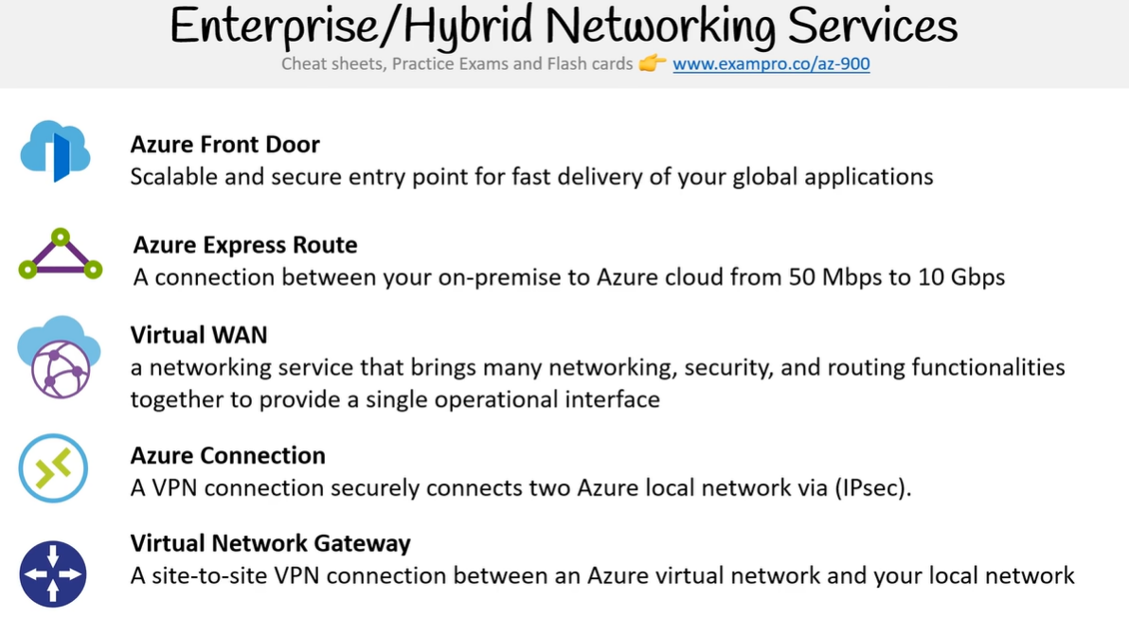

* **⌨️ (**[**01:31:26**](https://www.youtube.com/watch?v=NKEFWyqJ5XA&t=5486s)**) Azure Traffic Manager**

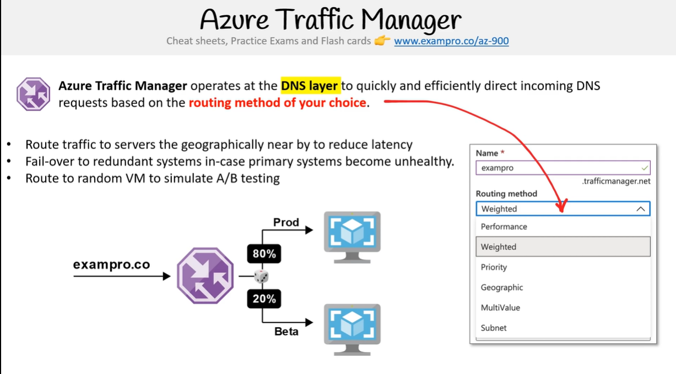

* **⌨️ (**[**01:32:34**](https://www.youtube.com/watch?v=NKEFWyqJ5XA&t=5554s)**) Azure DNS**

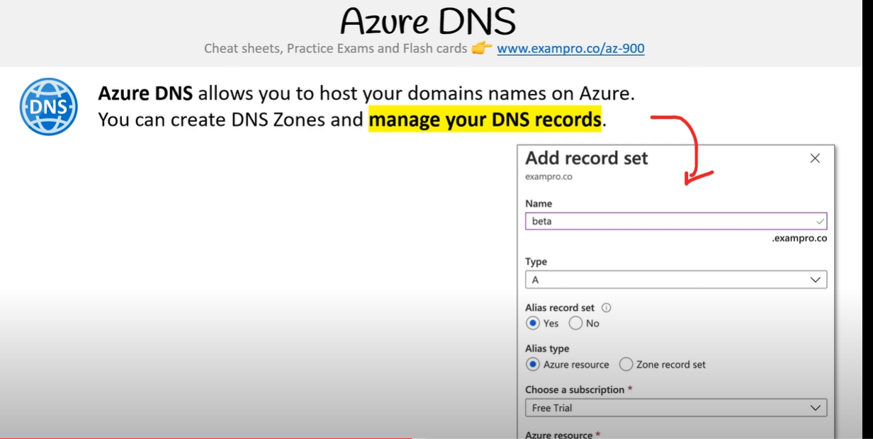

* **⌨️ (**[**01:33:32**](https://www.youtube.com/watch?v=NKEFWyqJ5XA&t=5612s)**) Azure Load Balancer**

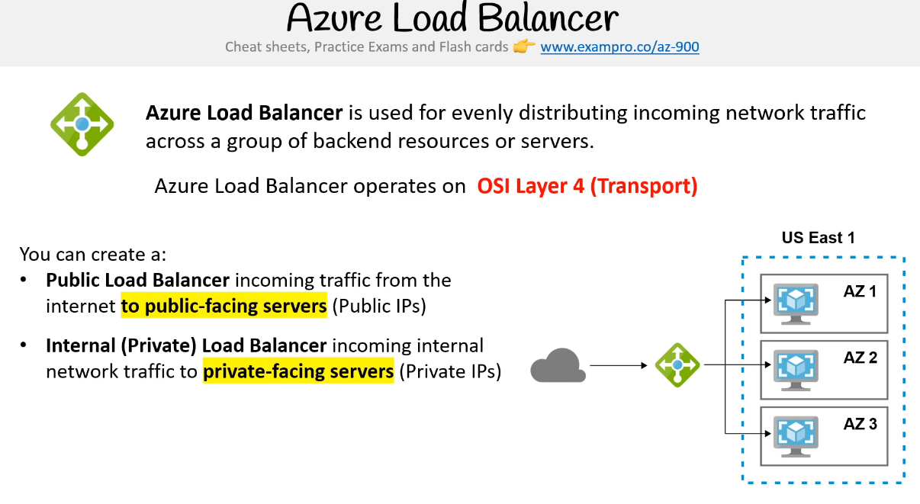

* **⌨️ (**[**01:34:56**](https://www.youtube.com/watch?v=NKEFWyqJ5XA&t=5696s)**) Scale Sets**

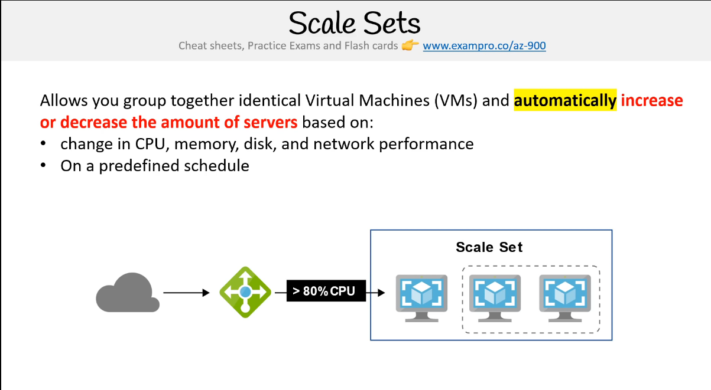

* ⌨️ ([01:36:00](https://www.youtube.com/watch?v=NKEFWyqJ5XA&t=5760s)) IoT Services
* ⌨️ ([01:38:21](https://www.youtube.com/watch?v=NKEFWyqJ5XA&t=5901s)) Big Data and Analytics Services

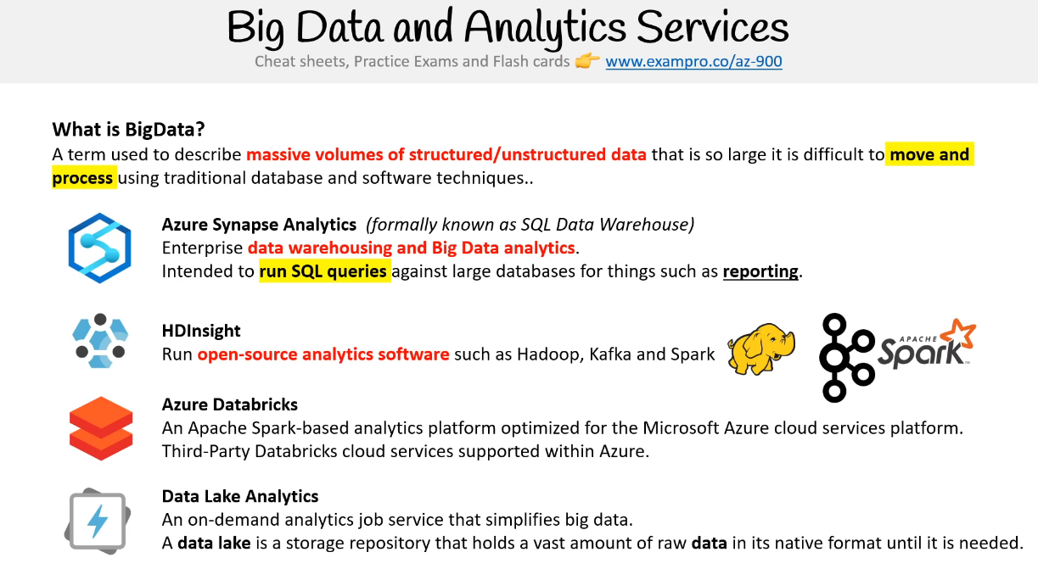

* ⌨️ ([01:40:11](https://www.youtube.com/watch?v=NKEFWyqJ5XA&t=6011s)) AI ML Services Introduction
* ⌨️ ([01:42:21](https://www.youtube.com/watch?v=NKEFWyqJ5XA&t=6141s)) AI ML Services
* ⌨️ ([01:44:00](https://www.youtube.com/watch?v=NKEFWyqJ5XA&t=6240s)) Serverless Services

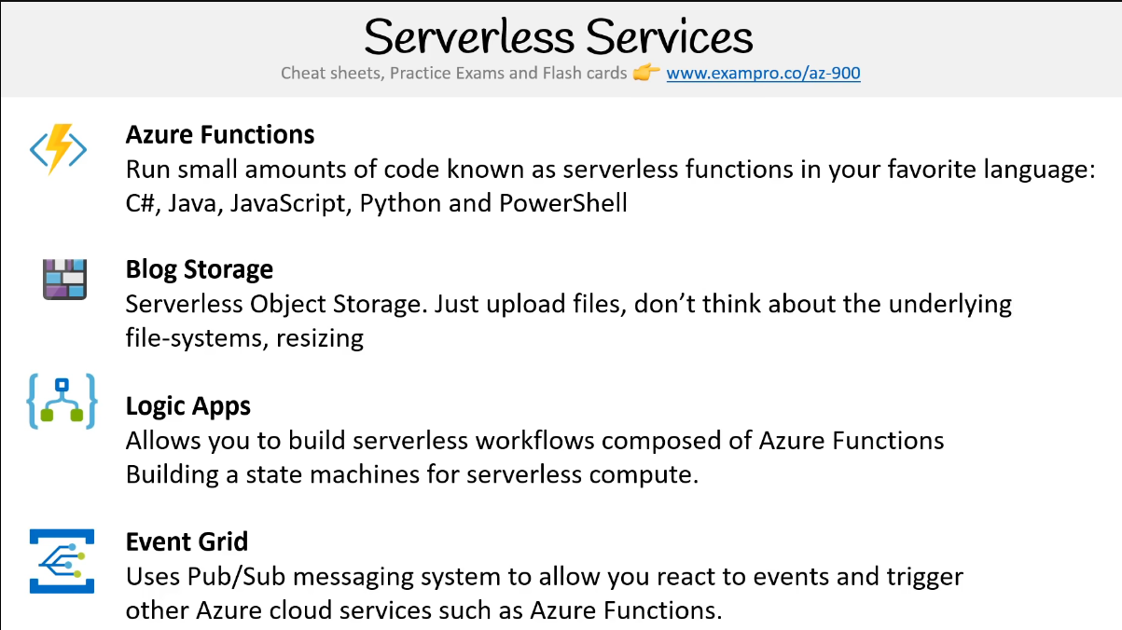

**☁️ Management Tools**

* ⌨️ ([01:46:07](https://www.youtube.com/watch?v=NKEFWyqJ5XA&t=6367s)) Azure Portal
* ⌨️ ([01:48:00](https://www.youtube.com/watch?v=NKEFWyqJ5XA&t=6480s)) PowerShell
* ⌨️ ([01:50:00](https://www.youtube.com/watch?v=NKEFWyqJ5XA&t=6600s)) Visual Studio Code
* ⌨️ ([01:51:52](https://www.youtube.com/watch?v=NKEFWyqJ5XA&t=6712s)) Cloud Shell
* ⌨️ ([01:52:43](https://www.youtube.com/watch?v=NKEFWyqJ5XA&t=6763s)) Azure CLI

**☁️ Follow Along**

* ⌨️ ([01:54:03](https://www.youtube.com/watch?v=NKEFWyqJ5XA&t=6843s)) Create a Resource Group
* ⌨️ ([01:55:55](https://www.youtube.com/watch?v=NKEFWyqJ5XA&t=6955s)) Create a vNet
* ⌨️ ([01:58:26](https://www.youtube.com/watch?v=NKEFWyqJ5XA&t=7106s)) Launching a Server
* ⌨️ ([02:04:16](https://www.youtube.com/watch?v=NKEFWyqJ5XA&t=7456s)) Creating a Azure Function
* ⌨️ ([02:08:44](https://www.youtube.com/watch?v=NKEFWyqJ5XA&t=7724s)) Storing files in Blob Storage
* ⌨️ ([02:12:08](https://www.youtube.com/watch?v=NKEFWyqJ5XA&t=7928s)) Exploring Azure Cloud Shell

**☁️ Security**

* ⌨️ ([02:13:52](https://www.youtube.com/watch?v=NKEFWyqJ5XA&t=8032s)) Azure Trust Center
* ⌨️ ([02:15:48](https://www.youtube.com/watch?v=NKEFWyqJ5XA&t=8148s)) Compliance Programs
* **⌨️ (**[**02:19:25**](https://www.youtube.com/watch?v=NKEFWyqJ5XA&t=8365s)**) Azure Active Directory**

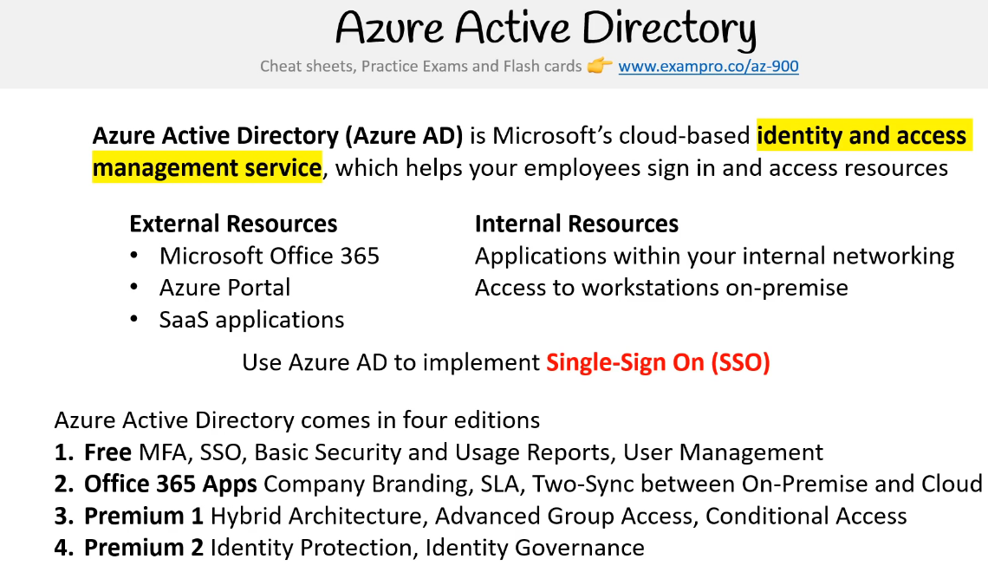

* ⌨️ ([02:21:14](https://www.youtube.com/watch?v=NKEFWyqJ5XA&t=8474s)) MFA
* ⌨️ ([02:22:50](https://www.youtube.com/watch?v=NKEFWyqJ5XA&t=8570s)) Azure Security Center
* ⌨️ ([02:23:31](https://www.youtube.com/watch?v=NKEFWyqJ5XA&t=8611s)) Key Vault

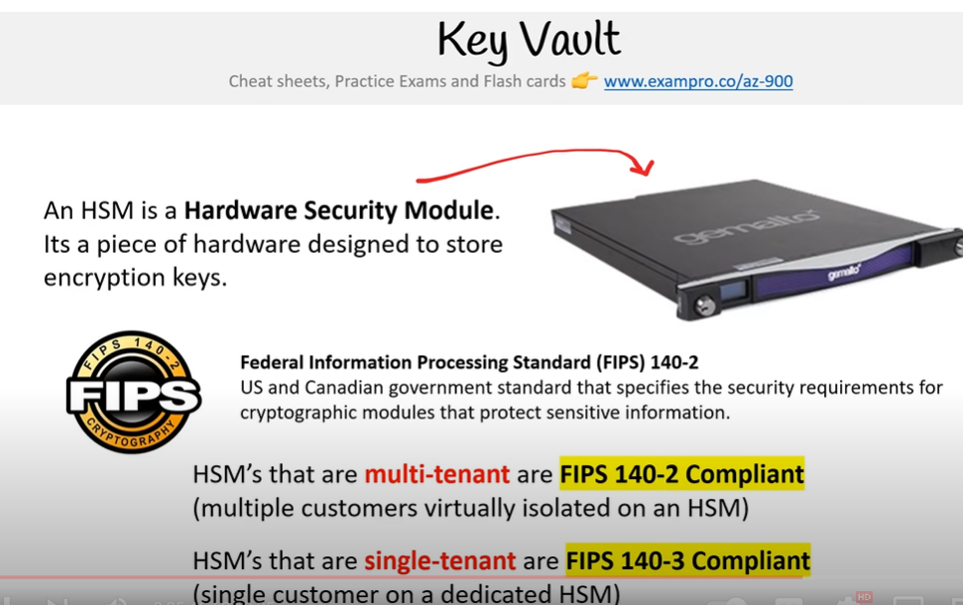mouys

* ⌨️ ([02:25:55](https://www.youtube.com/watch?v=NKEFWyqJ5XA&t=8755s)) Azure DDoS Protection
* ⌨️ ([02:28:26](https://www.youtube.com/watch?v=NKEFWyqJ5XA&t=8906s)) Azure Firewall

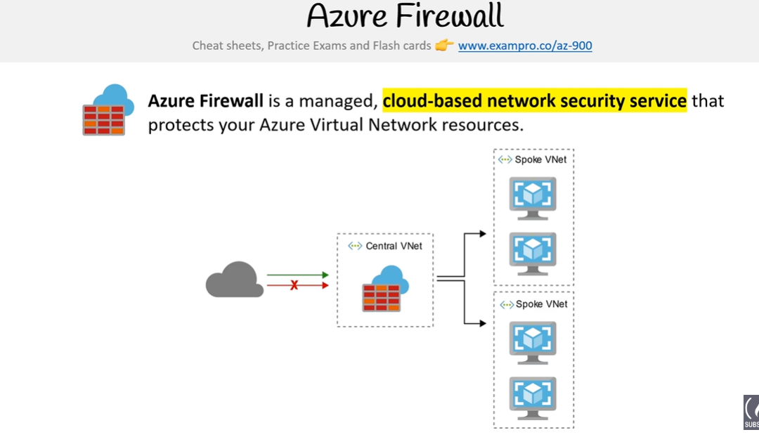

* ⌨️ ([02:30:12](https://www.youtube.com/watch?v=NKEFWyqJ5XA&t=9012s)) Azure Information Protection

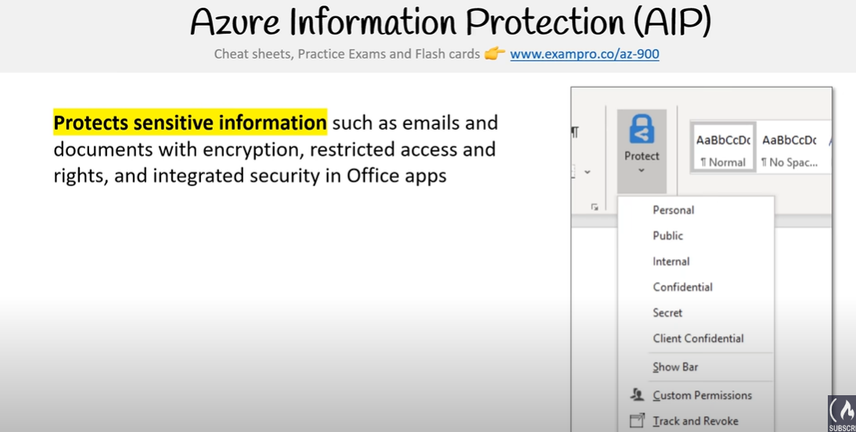

* ⌨️ ([02:31:02](https://www.youtube.com/watch?v=NKEFWyqJ5XA&t=9062s)) Application Gateway

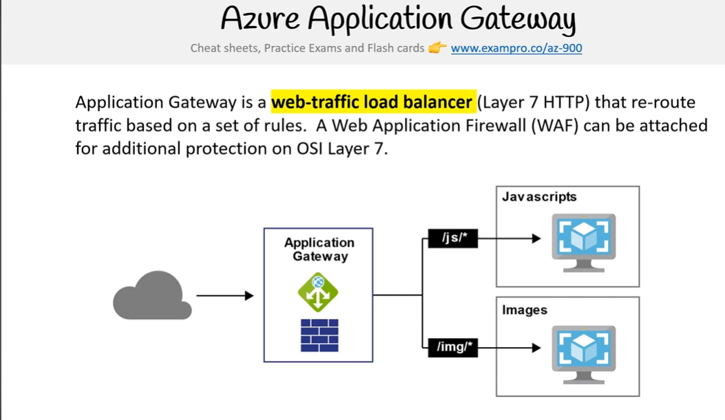

* ⌨️ ([02:32:22](https://www.youtube.com/watch?v=NKEFWyqJ5XA&t=9142s)) Advanced Threat Protection ATP

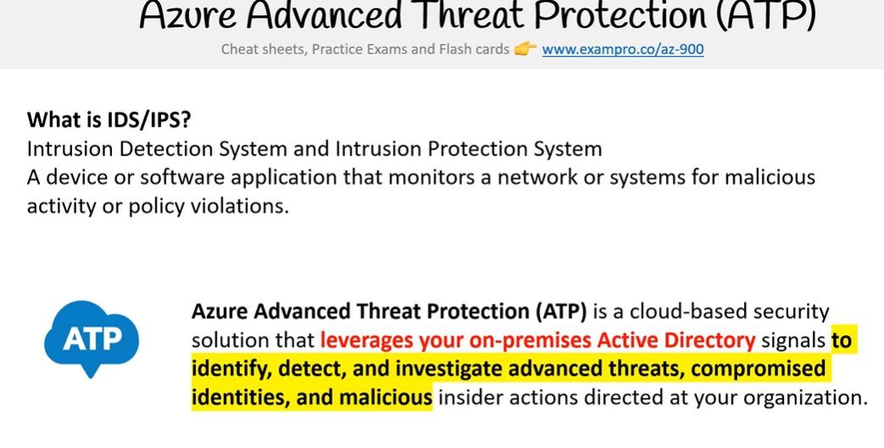

* ⌨️ ([02:33:40](https://www.youtube.com/watch?v=NKEFWyqJ5XA&t=9220s)) Microsoft Security Development Lifecycle SDL

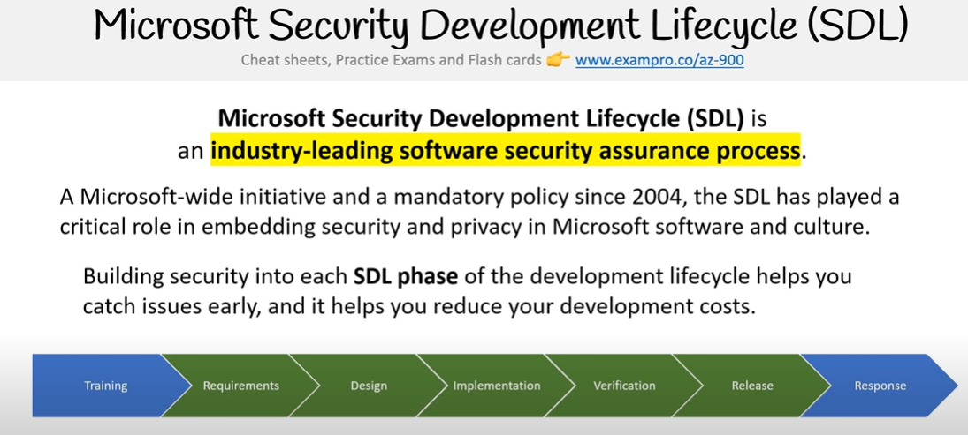

* ⌨️ ([02:35:02](https://www.youtube.com/watch?v=NKEFWyqJ5XA&t=9302s)) Azure Policies

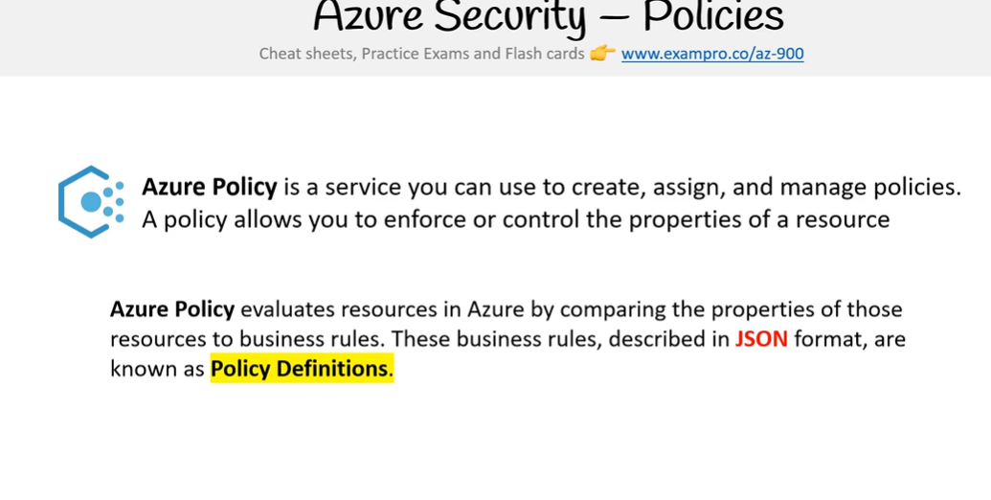

* ⌨️ ([02:35:44](https://www.youtube.com/watch?v=NKEFWyqJ5XA&t=9344s)) Role Based Access Control RBAC

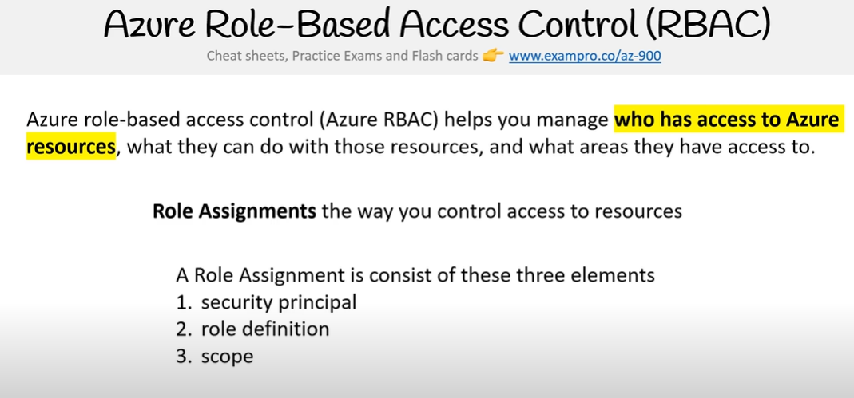

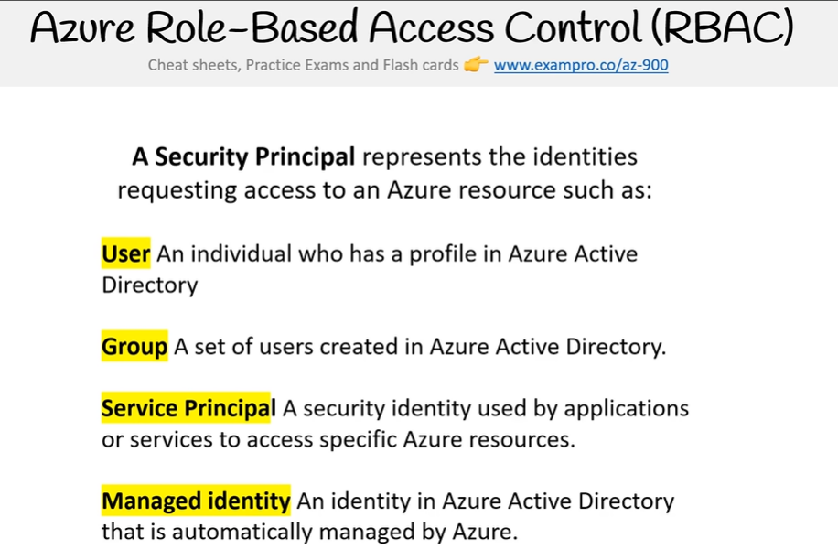

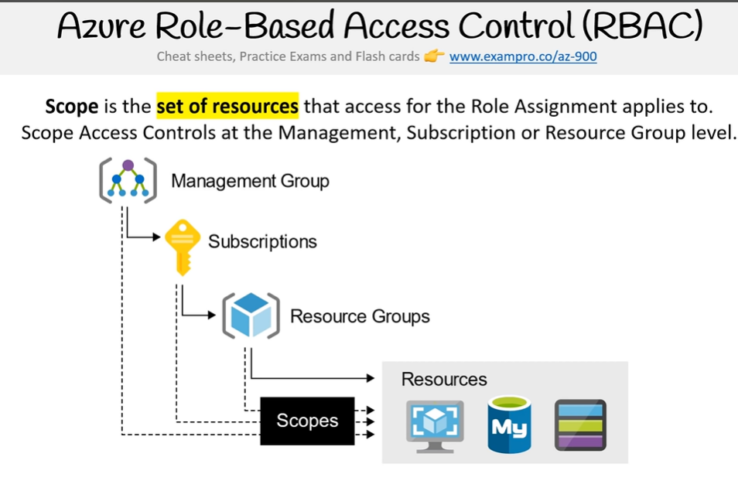

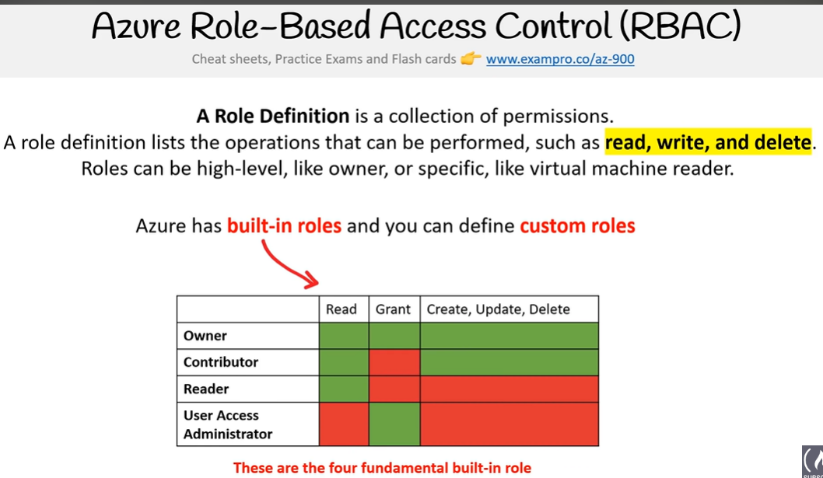

* ⌨️ ([02:39:17](https://www.youtube.com/watch?v=NKEFWyqJ5XA&t=9557s)) Lock resources
* ⌨️ ([02:40:07](https://www.youtube.com/watch?v=NKEFWyqJ5XA&t=9607s)) Management Groups

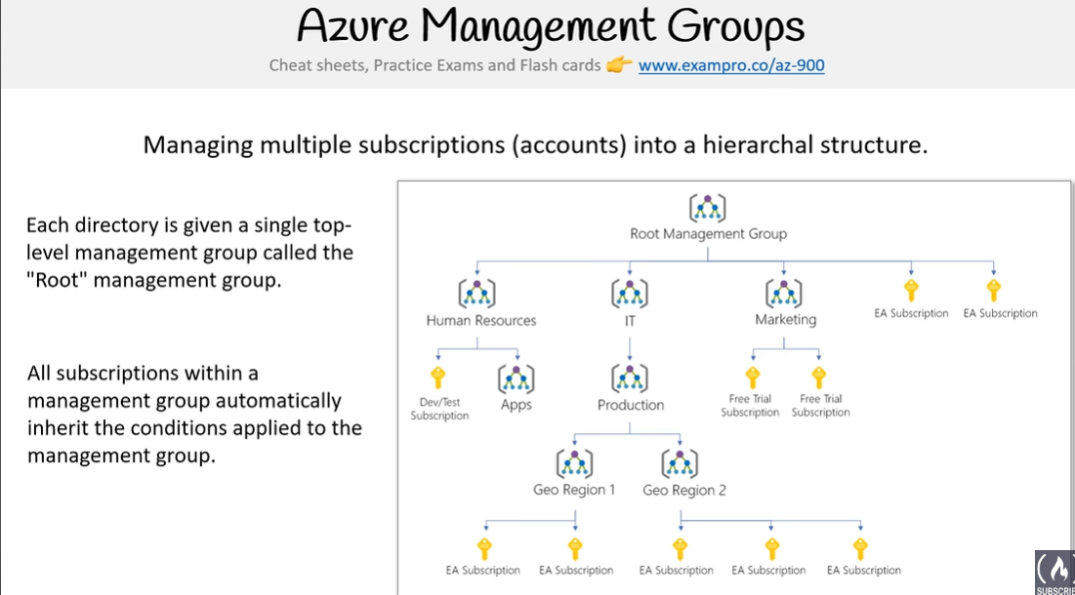

* ⌨️ ([02:40:58](https://www.youtube.com/watch?v=NKEFWyqJ5XA&t=9658s)) Azure Monitor
* ⌨️ ([02:41:52](https://www.youtube.com/watch?v=NKEFWyqJ5XA&t=9712s)) Service Health
* ⌨️ ([02:42:39](https://www.youtube.com/watch?v=NKEFWyqJ5XA&t=9759s)) Azure Advisor

**☁️ Billing and Pricing**

* ⌨️ ([02:43:38](https://www.youtube.com/watch?v=NKEFWyqJ5XA&t=9818s)) Service Level Agreements
* ⌨️ ([02:46:12](https://www.youtube.com/watch?v=NKEFWyqJ5XA&t=9972s)) Service Credits
* ⌨️ ([02:47:40](https://www.youtube.com/watch?v=NKEFWyqJ5XA&t=10060s)) Composite SLAs
* ⌨️ ([02:49:50](https://www.youtube.com/watch?v=NKEFWyqJ5XA&t=10190s)) TCO Calculator
  + https://azure.microsoft.com/en-in/pricing/tco/calculator/
* ⌨️ ([02:52:34](https://www.youtube.com/watch?v=NKEFWyqJ5XA&t=10354s)) Azure Marketplace
* ⌨️ ([02:54:21](https://www.youtube.com/watch?v=NKEFWyqJ5XA&t=10461s)) Azure Support
* ⌨️ ([03:00:02](https://www.youtube.com/watch?v=NKEFWyqJ5XA&t=10802s)) Azure Licensing
* ⌨️ ([03:02:03](https://www.youtube.com/watch?v=NKEFWyqJ5XA&t=10923s)) Azure Subscriptions
* ⌨️ ([03:04:15](https://www.youtube.com/watch?v=NKEFWyqJ5XA&t=11055s)) Pricing Calculator
* ⌨️ ([03:06:41](https://www.youtube.com/watch?v=NKEFWyqJ5XA&t=11201s)) Azure Cost Management

**☁️ Summary**

* ⌨️ ([03:07:19](https://www.youtube.com/watch?v=NKEFWyqJ5XA&t=11239s)) Booking Your Exam

<https://home.pearsonvue.com/>